Name: David Bijak Santoso

Class: L1BC

Course: Algorithm and Programming

**Project Final Game**

1. **Project Documentation**
2. Brief Description

This project was made for Algorithm and Programming course final semester result. The project is to make a functional game using only python programming language. The game was based on a tutorial video and the concept was about free falling and dodging enemies. The title is called “Rose Fall!” and the game is based on a Nijisanji character Rosemi Lovelock. Game was designed for a fan made vtuber style video game that is simple and easy to understand on the objective. It uses various assets that suits the vibe for the gameplay, for example pink colour for the background and clouds. Also, the player controls chibi pudding shape Rosemi to add the fun for the gameplay. The game mechanic is simple, players fall and dodges enemies. There are cloud platforms to prevent getting hit by enemies and players may uses it in various ways depends on their gameplay.

1. Use-case Diagram

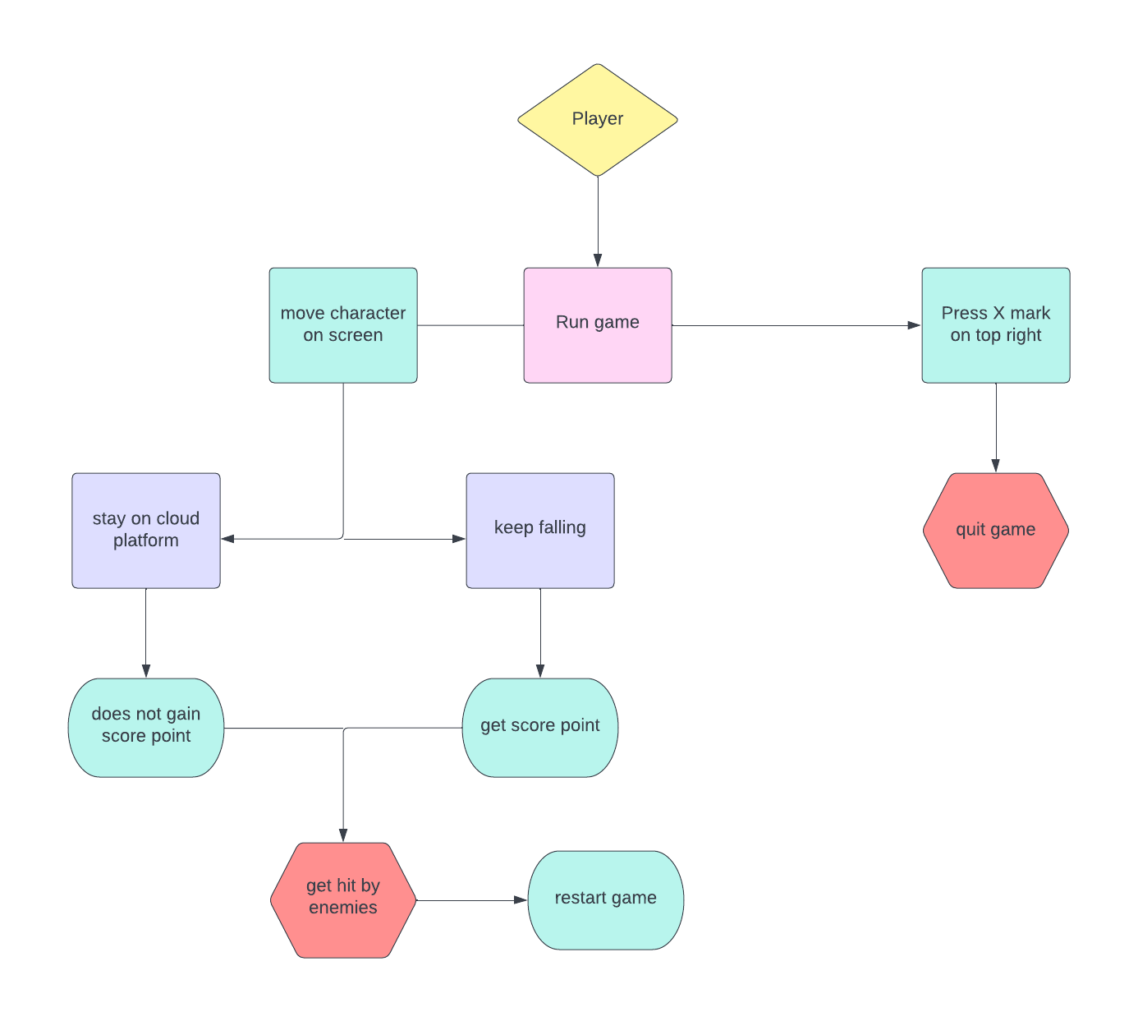

1. 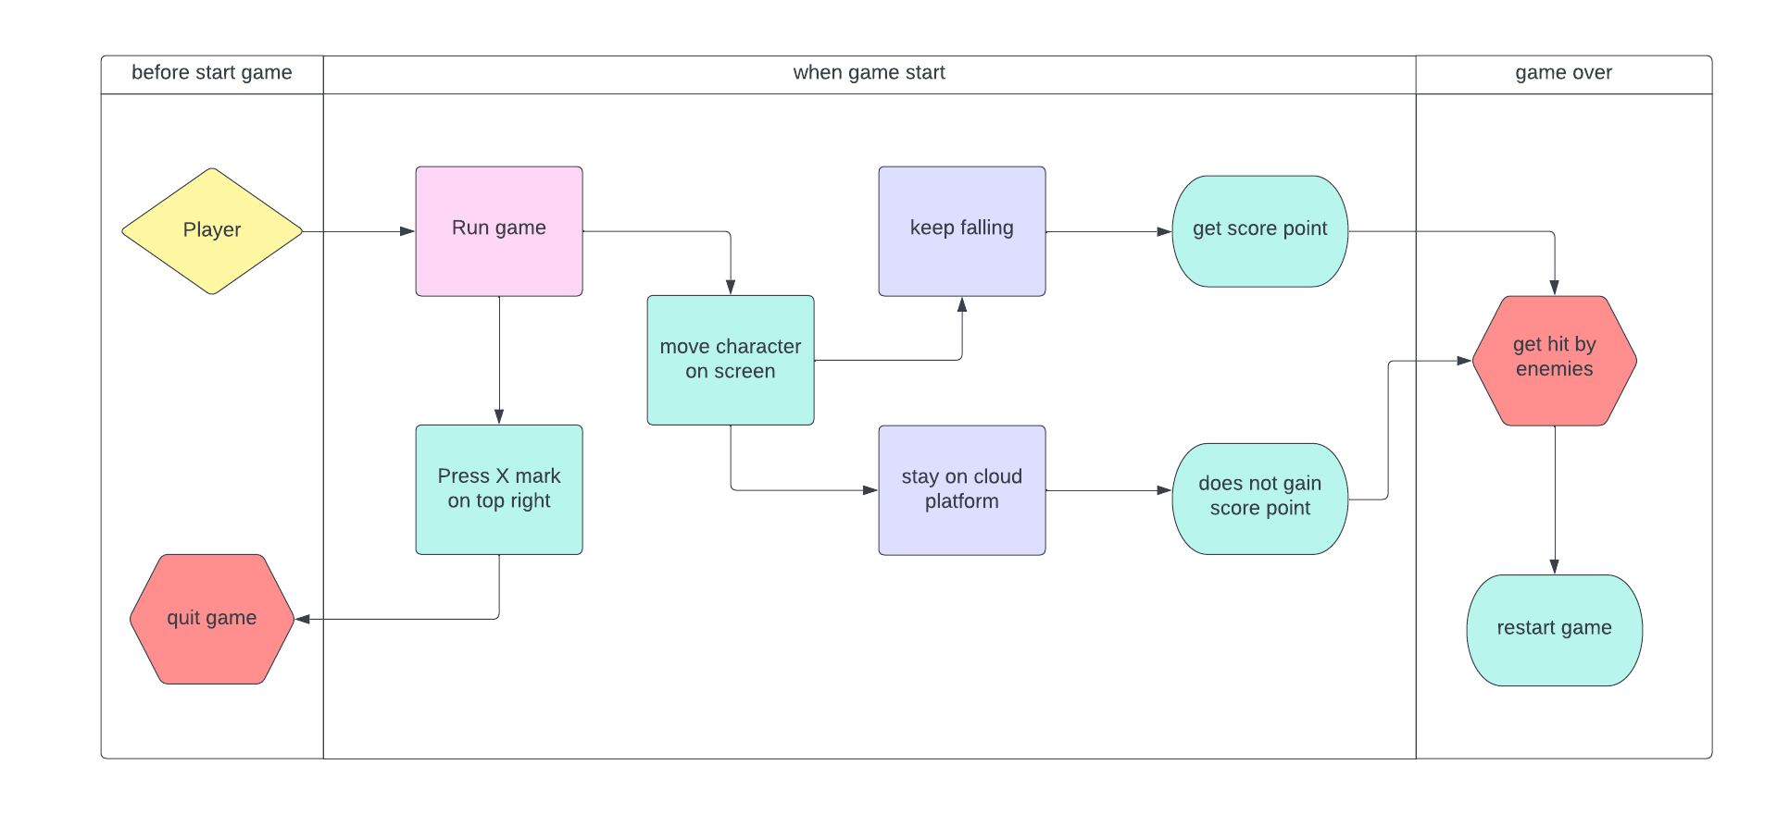Activity Diagram
2. 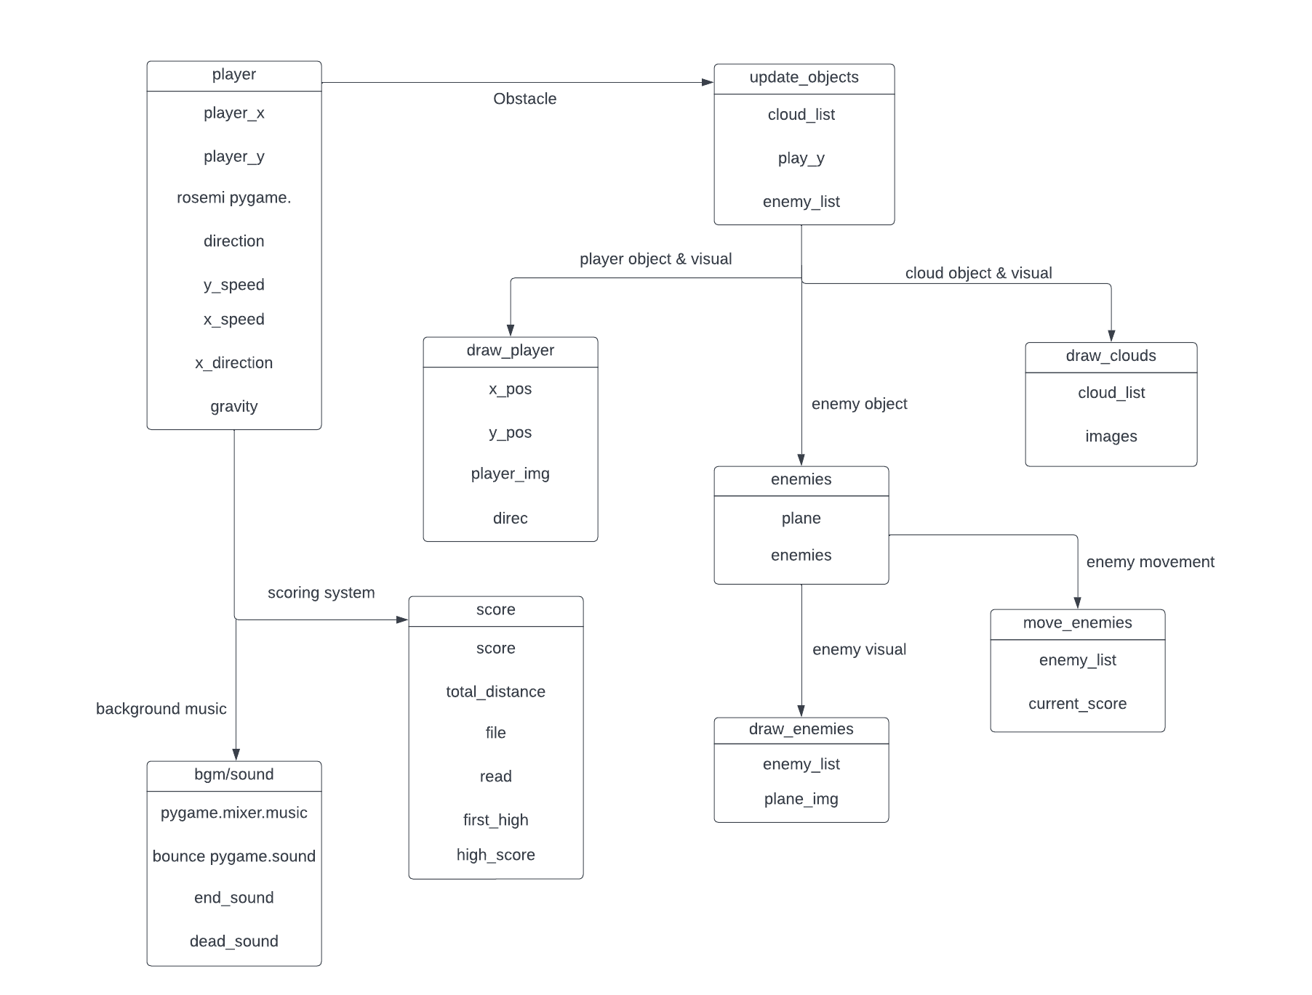Class Diagram
3. 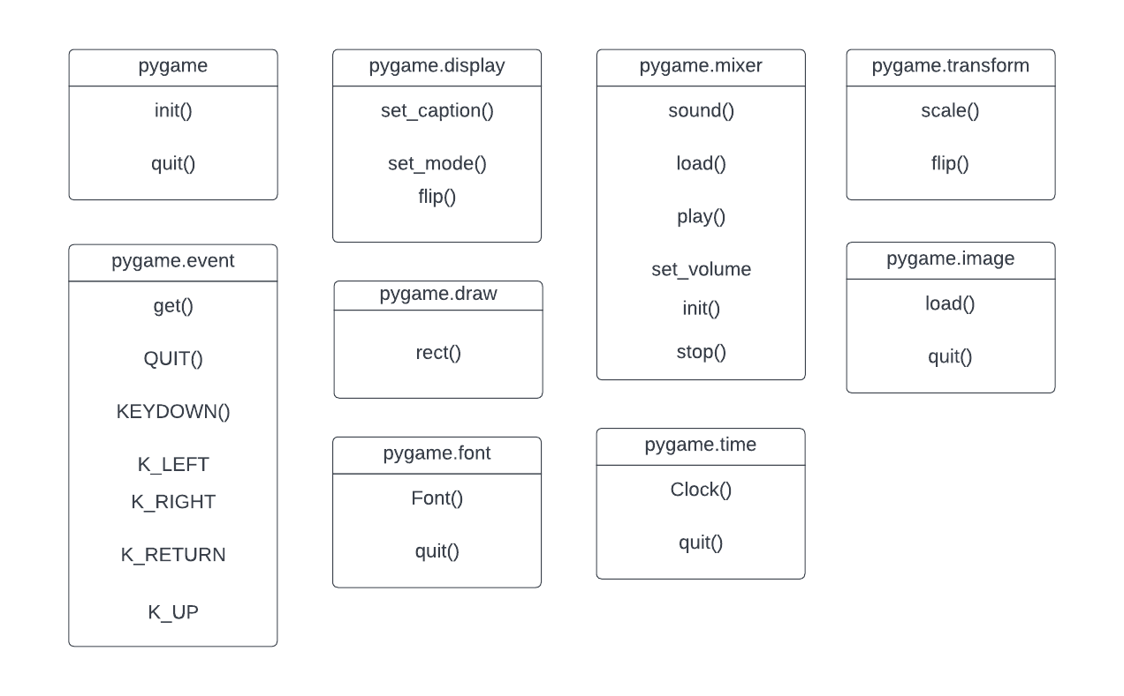Modules
4. Essential Algorithms

update_objects = This is a function to create an infinite loop that can display in the gameplay for the core mechanics.

def update_objects(cloud_list, play_y, enemy_list):🡨variables to use

    lowest_cloud = 0 🡨lowest cloud that could randomly spawn in display

    update_speed = 10 🡨speed to increase difficulty and cloud random generate

    if play_y > 200: 🡨vertical position to generate display if speed is high

        play_y -= update_speed

        for q in range(len(enemy_list)): 🡨enemy display

            enemy_list[q][1] -= update_speed

        for j in range(len(cloud_list)): 🡨cloud display

            cloud_list[j][1] -= update_speed

            if cloud_list[j][1] > lowest_cloud: 🡨for lowest cloud

                lowest_cloud = cloud_list[j][1]

        if lowest_cloud < 750: 🡨for generating clouds

            num_clouds = random.randint(1,2)

            if num_clouds == 1:

                x_pos = random.randint(0, WIDTH - 70) 🡨x position for cloud

                y_pos = random.randint(HEIGHT + 100, HEIGHT + 300)🡨y position

                cloud_type = random.randint (1, 3) 🡨type of cloud assets

                cloud_list.append([x_pos, y_pos, cloud_type]) 🡨display clouds

            else:

                x_pos = random.randint(0, WIDTH/2 - 70) 🡨x position for cloud

                y_pos = random.randint(HEIGHT + 100, HEIGHT + 300)

                cloud_type = random.randint (1, 3)🡨type of cloud assets

                x_pos2 = random.randint(WIDTH/2 + 70, WIDTH - 70)🡨x position

                y_pos2 = random.randint(HEIGHT + 100, HEIGHT + 300) 🡨for y

                cloud_type2 = random.randint (1, 3) 🡨type of cloud assets

                cloud_list.append([x_pos, y_pos, cloud_type]) 🡨display clouds

                cloud_list.append([x_pos2, y_pos2, cloud_type2])🡨display ^^

    return play_y, cloud_list, enemy_list 🡨return list variable

draw_clouds = This is a function to create clouds on display by using assets and use as platform on gameplay player’s perspective.

def draw_clouds(cloud_list, images): 🡨variables to use

    platforms = [] <--to return cloud platforms and make collusion

    for j in range(len(cloud_list)):

        image = images[cloud_list[j][2] - 1] 🡨assets to use for cloud

        platform = pygame.rect.Rect((cloud_list[j][0] + 5, cloud_list[j][1] + 70), (100, 10)) 🡨hitmarker for clouds

        screen.blit(image, (cloud_list[j][0], cloud_list[j][1])) 🡨display clouds on screen

        pygame.draw.rect(screen, 'pink', [cloud_list[j][0] + 5, cloud_list[j][1] + 70, 100, 3]) 🡨use only for displaying hitmarker

        platforms.append(platform) 🡨to show it/visible on screen

    return platforms 🡨return variable

draw_player = This is a function to create player on display by using assets and to control the character for the player to move.

def draw_player(x_pos, y_pos, player_img, direc): 🡨variables to use

    if direc == -1: 🡨if player bounce up character flip body 180

        player_img = pygame.transform.flip(player_img, False, True) 🡨flip

    screen.blit(player_img, (x_pos, y_pos)) 🡨display player on screen

    player_rect = pygame.rect.Rect((x_pos + 7, y_pos + 32), (36, 10))🡨hitmark

    #pygame.draw.rect(screen, 'green', player_rect, 3)🡨use to display hitmark

    return player_rect 🡨return variable

draw_enemies = This is a function to create enemies (plane) on display by using assets and to use as an obstacle for player to avoid.

def draw_enemies(enemy_list, plane_img): 🡨variables to use

    enemy_rects = [] 🡨to make enemy hitmark

    for j in range(len(enemy_list)):

        enemy_rect = pygame.rect.Rect((enemy_list[j][0] - 1, enemy_list[j][1] + 80), (300, 80)) 🡨hitmarker for enemy

        #pygame.draw.rect(screen, 'orange', enemy_rect, 3)🡨to display hitmark

        enemy_rects.append(enemy_rect) 🡨to show hitmark visible

        if enemy_list[j][2] == 1: 🡨display shark on right position

            screen.blit(plane_img, (enemy_list[j][0], enemy_list[j][1]))

        elif enemy_list[j][2] == -1: 🡨display shark on left position

            screen.blit(pygame.transform.flip(plane_img, 1, 0), (enemy_list[j][0], enemy_list[j][1])) 🡨flipping enemy viewpoint

    return enemy_rects 🡨return variable

move_enemies = This is a function to create enem(ies)y movement on display to make gameplay immersive, fun, and difficult.

def move_enemies(enemy_list, current_score): 🡨variables to use

    enemy_speed = 2 + current_score//15 🡨enemies become hard/difficulty

    for j in range(len(enemy_list)): 🡨move enemy from left and right

        if enemy_list[j][2] == 1:

            if enemy_list[j][0] < WIDTH: 🡨code for enemy right to left

                enemy_list[j][0] += enemy_speed 🡨enemy speed

            else:

                enemy_list[j][2] = -1 🡨enemy starting position

        elif enemy_list[j][2] == -1:

            if enemy_list[j][0] > -320: 🡨code for enemy left to right

                enemy_list[j][0] -= enemy_speed 🡨enemy speed

            else:

                enemy_list[j][2] = 1 🡨enemy starting position

        if enemy_list[j][1] < -100:

            enemy_list[j][1] = random.randint(HEIGHT, HEIGHT + 500) 🡨area enemies spawn

    return enemy_list 🡨return variable

1. Screenshot for Application

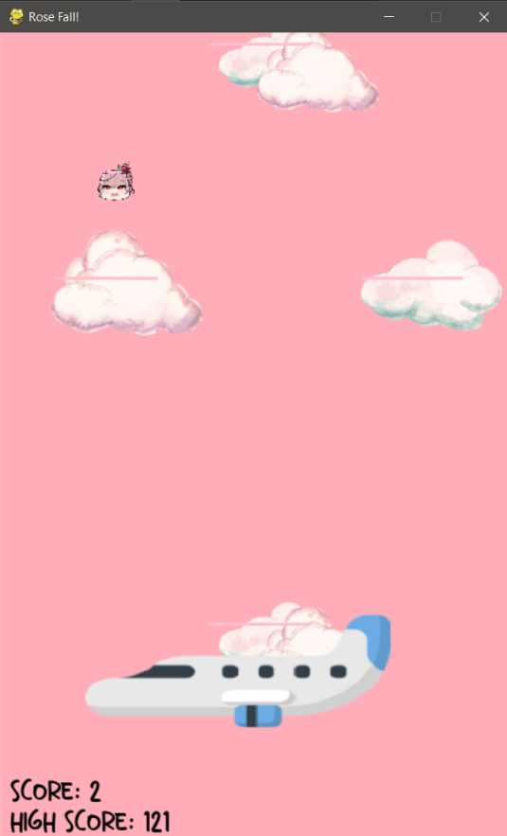

1. Lesson Learned/Reflection

What I have learned is that using pygame takes a lot of fail and retry. I may know the keywords, variables, and correct variables to create lines of codes, but I still haven’t try to diverse and understand fully the concept of them. I may try do experiments and testing, although I’ll wait until the second semester to start the course so I can follow the materials without forgetting them since I always do. On the other hand, I had fun in this project and it motivates me wanting to try more if the times come though.

1. **Program/Source Code**

#Rose Fall! (Rosemi-sama)

#game inspiration from https://www.youtube.com/watch?v=VhX1hicQo00&t=2349s

#game description: Game where player main task is to fall while dodging enemies and moving from platform to another

import pygame 🡨import this is a must for pygames

import random 🡨for assets

#all this for storing variables

pygame.init() 🡨random generator

pygame.mixer.init() 🡨background music

WIDTH = 500 🡨screen width size

HEIGHT = 800 🡨screen height size

fps = 60 🡨fps

timer = pygame.time.Clock() 🡨timer tell how many times it tick

huge_font = pygame.font.Font('assets/font.ttf', 42)🡨Main title

font = pygame.font.Font('assets/font.ttf', 24) 🡨font

pygame.display.set_caption('Rose Fall!')🡨caption title

screen = pygame.display.set_mode([WIDTH, HEIGHT]) 🡨screen display

bg = (255, 174, 185) 🡨color background

game_over = False 🡨game over scenario

clouds = [[200, 100, 1], [50, 330, 2], [350, 330, 3], [200, 670, 1]] 🡨clouds x,y coordinates

cloud_images = [] 🡨cloud images

for i in range(1, 4): 🡨command to create cloud images

    img = pygame.image.load(f'assets/clouds/cloud{i}.png')

    cloud_images.append(img)

#player variables

player_x = 240 🡨x position

player_y = 40 🡨y position

rosemi = pygame.transform.scale(pygame.image.load('assets/rosemilovelock.png'), (50, 50)) 🡨assets

direction = -1 🡨going down

y_speed = 0 🡨vertical speed

gravity = 0.3 🡨gravity yes physics does exist in pygame smh

x_speed = 3 🡨horizontal speed

x_direction = 0 🡨direction

#score variables

score = 0 🡨score

total_distance = 0 🡨distance for the scoring system

file = open('high_scores.txt', 'r') 🡨to save high score

read = file.readlines() 🡨to put high score system

first_high = int(read[0])

high_score = first_high

#enemies variables

plane = pygame.transform.scale(pygame.image.load('assets/plane.png'), (300, 200)) 🡨enemy assets

enemies = [[-234, random.randint(400, HEIGHT - 100), 1]] 🡨plane x y coordinates

#sounds and bgm

pygame.mixer.music.load('assets/theme.mp3') 🡨bgm

bounce = pygame.mixer.Sound('assets/bounce.mp3') 🡨bounce noise

end_sound = pygame.mixer.Sound('assets/game_over.mp3') 🡨end theme/game over

end_sound.set_volume(0.2) 🡨volume sound for game over

dead_sound = pygame.mixer.Sound('assets/wee.mp3') 🡨death noise

pygame.mixer.music.play() 🡨play when game start

pygame.mixer.music.play(-1) 🡨for looping

pygame.mixer.music.set_volume(0.2) 🡨volume sound for bgm

#function to create and draw clouds in display

#VVVVVVVVV

def draw_clouds(cloud_list, images): 🡨variables to use

    platforms = [] 🡨to return cloud platforms and make collusion

    for j in range(len(cloud_list)):

        image = images[cloud_list[j][2] - 1] 🡨assets to use for cloud

        platform = pygame.rect.Rect((cloud_list[j][0] + 5, cloud_list[j][1] + 70), (100, 10)) 🡨hitmarker for clouds

        screen.blit(image, (cloud_list[j][0], cloud_list[j][1])) 🡨display clouds on screen

        pygame.draw.rect(screen, 'pink', [cloud_list[j][0] + 5, cloud_list[j][1] + 70, 100, 3]) 🡨use only for displaying hitmarker

        platforms.append(platform) 🡨to show it/visible on screen

    return platforms 🡨return variable

#function to create and draw player in display

#VVVVVVV

def draw_player(x_pos, y_pos, player_img, direc): 🡨variables to use

    if direc == -1: 🡨if player bounce up character flip body 180

        player_img = pygame.transform.flip(player_img, False, True) 🡨flip

    screen.blit(player_img, (x_pos, y_pos)) 🡨display player on screen

    player_rect = pygame.rect.Rect((x_pos + 7, y_pos + 32), (36, 10))🡨hitmark

    #pygame.draw.rect(screen, 'green', player_rect, 3)🡨use to display hitmark

    return player_rect 🡨return variable

#function to create and draw enemy in display

#VVVVVVVV

def draw_enemies(enemy_list, plane_img): 🡨variables to use

    enemy_rects = [] 🡨to make enemy hitmark

    for j in range(len(enemy_list)):

        enemy_rect = pygame.rect.Rect((enemy_list[j][0] - 1, enemy_list[j][1] + 80), (300, 80)) 🡨hitmarker for enemy

        #pygame.draw.rect(screen, 'orange', enemy_rect, 3)🡨to display hitmark

        enemy_rects.append(enemy_rect) 🡨to show hitmark visible

        if enemy_list[j][2] == 1: 🡨display shark on right position

            screen.blit(plane_img, (enemy_list[j][0], enemy_list[j][1]))

        elif enemy_list[j][2] == -1: 🡨display shark on left position

            screen.blit(pygame.transform.flip(plane_img, 1, 0), (enemy_list[j][0], enemy_list[j][1])) 🡨flipping enemy viewpoint

    return enemy_rects 🡨return variable

#function to create enemy movement

#VVVVVV

def move_enemies(enemy_list, current_score): 🡨variables to use

    enemy_speed = 2 + current_score//15 🡨enemies become hard/difficulty

    for j in range(len(enemy_list)): 🡨move enemy from left and right

        if enemy_list[j][2] == 1:

            if enemy_list[j][0] < WIDTH: 🡨code for enemy right to left

                enemy_list[j][0] += enemy_speed 🡨enemy speed

            else:

                enemy_list[j][2] = -1 🡨enemy starting position

        elif enemy_list[j][2] == -1:

            if enemy_list[j][0] > -320: 🡨code for enemy left to right

                enemy_list[j][0] -= enemy_speed 🡨enemy speed

            else:

                enemy_list[j][2] = 1 🡨enemy starting position

        if enemy_list[j][1] < -100:

            enemy_list[j][1] = random.randint(HEIGHT, HEIGHT + 500) 🡨area enemies spawn

    return enemy_list 🡨return variable

#function to create infinite loop

#VVVVVV

def update_objects(cloud_list, play_y, enemy_list):🡨variables to use

    lowest_cloud = 0 🡨lowest cloud that could randomly spawn in display

    update_speed = 10 🡨speed to increase difficulty and cloud random generate

    if play_y > 200: 🡨vertical position to generate display if speed is high

        play_y -= update_speed

        for q in range(len(enemy_list)): 🡨enemy display

            enemy_list[q][1] -= update_speed

        for j in range(len(cloud_list)): 🡨cloud display

            cloud_list[j][1] -= update_speed

            if cloud_list[j][1] > lowest_cloud: 🡨for lowest cloud

                lowest_cloud = cloud_list[j][1]

        if lowest_cloud < 750: 🡨for generating clouds

            num_clouds = random.randint(1,2)

            if num_clouds == 1:

                x_pos = random.randint(0, WIDTH - 70) 🡨x position for cloud

                y_pos = random.randint(HEIGHT + 100, HEIGHT + 300)🡨y position

                cloud_type = random.randint (1, 3) 🡨type of cloud assets

                cloud_list.append([x_pos, y_pos, cloud_type]) 🡨display clouds

            else:

                x_pos = random.randint(0, WIDTH/2 - 70) 🡨x position for cloud

                y_pos = random.randint(HEIGHT + 100, HEIGHT + 300)

                cloud_type = random.randint (1, 3)🡨type of cloud assets

                x_pos2 = random.randint(WIDTH/2 + 70, WIDTH - 70)🡨x position

                y_pos2 = random.randint(HEIGHT + 100, HEIGHT + 300) 🡨for y

                cloud_type2 = random.randint (1, 3) 🡨type of cloud assets

                cloud_list.append([x_pos, y_pos, cloud_type]) 🡨display clouds

                cloud_list.append([x_pos2, y_pos2, cloud_type2])🡨display ^^

    return play_y, cloud_list, enemy_list 🡨return list variable

#main game to run and loop the infinite gameplay

run = True 🡨loop running

while run: 🡨for stuff you want to happen when loop

    screen.fill(bg) 🡨make background

    timer.tick(fps) 🡨fps for gameplay

    cloud_platforms = draw_clouds(clouds, cloud_images) 🡨clouds

    player = draw_player(player_x, player_y, rosemi, direction) 🡨player

    enemy_boxes = draw_enemies(enemies, plane) 🡨enemy

    enemies = move_enemies(enemies, score) 🡨enemy movement

    player_y, clouds, enemies = update_objects(clouds, player_y, enemies)

    if game_over: 🡨game over

        end_text = huge_font.render('Rose Fall!', True, 'red') 🡨end text

        end_text2 = font.render('Game Over: Press Enter to Restart', True, 'black') 🡨end text again

        screen.blit(end_text, (70,20)) 🡨show text on screen

        screen.blit(end_text2, (60,80)) 🡨show text on screen

        player_y = - 300

        y_speed = 0

    for i in range(len(cloud_platforms)): 🡨bounce effect

        if direction == -1 and player.colliderect(cloud_platforms[i]):

            y_speed *= -1 🡨player going up and down physics

            if y_speed > -2:

                y_speed = -2

            bounce.play() 🡨player hit clouds

    for event in pygame.event.get(): 🡨to quit while loop

        if event.type == pygame.QUIT: 🡨the x mark top right to quit

            run = False 🡨to quit game

        if event.type == pygame.KEYDOWN: 🡨up and down physics

            if event.key == pygame.K_LEFT:

                x_direction = -1

            elif event.key == pygame.K_RIGHT:

                x_direction = 1

            if event.key == pygame.K_RETURN and game_over: 🡨to restart game if game over

                game_over = False 🡨all of these are assets if game restart

                player_x = 240 <VVVVVVVVVVVVVVVVVVVVVVVVVVVVVVVVVVVVVVV

                player_y = 40

                direction = -1

                y_speed = 0

                x_direction = 0

                score = 0

                total_distance = 0

                enemies = [[-234, random.randint(400, HEIGHT - 100), 1]]

                clouds = [[200, 100, 1], [50, 330, 2], [350, 330, 3], [200, 670, 1]]

                end_sound.stop()

                pygame.mixer.music.play()

                pygame.mixer.music.play(-1)

        if event.type == pygame.KEYUP: 🡨player movement <>

            if event.key == pygame.K_LEFT: 🡨to move left

                x_direction = 0

            elif event.key == pygame.K_RIGHT: 🡨to move right

                x_direction = 0

    if y_speed < 10 and not game_over:

        y_speed += gravity 🡨moving collusion player

    player_y += y_speed

    if y_speed < 0:

        direction = 1

    else:

        direction = -1

    player_x += x_speed * x_direction

    if player_x > WIDTH: 🡨phasing through screen left and right

        player_x = -30

    elif player_x < -50:

        player_x = WIDTH - 20

    for i in range(len(enemy_boxes)): 🡨when die score gets record

        if player.colliderect(enemy_boxes[i]) and not game_over: 🡨when die

            end_sound.play()

            dead_sound.play()

            end_sound.play(-1)

            pygame.mixer.music.stop()

            game_over = True

            if score > first_high: 🡨if get high score

                file = open('high_scores.txt', 'w')

                write_score = str(score)

                file.write(write_score)

                file.close()

                first_high = score

    total_distance += y_speed 🡨display scores

    score = round(total_distance / 100)

    score_text = font.render(f'Score: {score}', True, 'black')

    screen.blit(score_text, (10, HEIGHT - 70))

    if score > high_score:🡨if score is more than high score it will highlight

        high_score = score 🡨replace new high score with old

    score_text2 = font.render(f'High Score: {high_score}', True, 'black')

    screen.blit(score_text2, (10, HEIGHT - 40))

    pygame.display.flip() 🡨to get out loop

pygame.quit() 🡨quit

1. **Presentation video**

